**A Project Report**

Submitted in partial fulfillment of the requirements for the award of the degree of

**MASTER’S**

In

**University of Missouri-Kansas City**

**Advance Software Engineering(CS5551)**

**Spring 2015**

Title: **BUDGET ANALYSIS AND REMAINDER**



Submitted By:

**Raghavendra Chirumamilla ( Class Id: 10 )**

**Sandhya Sannapareddy (Class Id: 45 )**

**Sampath Madineni ( Class Id: 30 )**

**Haricharana ( Class Id: 24 )**

Under the Esteemed Guidance of

**Dr. Yugyung.Lee**

TA : Malathy Krishnan, Chandra shekar, Mayanka, Bharath Viswanadam

**INDEX**

* + 1. **Deployment**
    2. **User Manual**
    3. **Project Management**
    4. **Project Proposal**
    5. **Project Plan**
    6. **Increment 1**
    7. **Increment 2**
    8. **Increment 3**
    9. **Presentation Material**
    10. **URL and Screenshot of Video**
    11. **References**
    12. **Acknowledgement**

**i. DEPLOYMENT**

**Source code and Documentation:-**

[**https://github.com/raghavach/final-Document**](https://github.com/raghavach/final-Document)

**Project Video** [**url :-**](url:-)

[**https://www.youtube.com/watch?v=HnFIWCn1msw**](https://www.youtube.com/watch?v=HnFIWCn1msw)

**ii. USER MANUAL**

**Introduction:**

In general people spend money at different places at different times. At the end of month they do not have any records and may suffer from crisis. To overcome this problem we developed an application, through which we can control our expenses and set budget limit in weekly, monthly or yearly basis.

This application notifies you when your expenses overcome the limit of your budget. So that one can have clear view of their expenses and control their over expenses.

**How to use the system:**

This is an android application which has some requirements such as

**Hardware Requirements:-**

A touch enabled smart phone with LED screen

RAM of capacity 512 MB

SD with minimum memory of 50 MB

1GHz processor or Dual core processor

**Software Requirements:-**

Operating System : Android

Version of operating system : gingerbread(2.3) or advanced

**Error recognition and handling:**

Users should register previously into application with required credentials and login with their valid credentials and set their budget limit and add their expenses on each purchase

**III. PROJECT MANAGEMENT**

**Summary:**

we have used agile process development model and completed the project in four increments. Each increment include both front end and backend implementation. scrumDo is used as a project management tool and maintain the project artifacts and individual role of all the team members. All of our team members contributed equally in developing both front end and back end the application.

The tasks of each increment and individual role for each increment is as following

**First Increment:**

1. identified functional and non functional requirements for the development of application.
2. Designing home screen, which contains options to register and login into application and database creation.

**Individual roles:**

*Raghavendra Chirumamilla:* validates the username and password during user login.

*Sandhya Sannapareddy:* user registration into application

*Sampath Madineni:* identifying functional and non-functional requirements.

*Haricharana:* when user gets registered username and password are saved to database.

**ScrumDo Link:**

You can find the related work and ScrumDo stories here:

<https://www.scrumdo.com/projects/project/budget-analysis-and-remainder4/iteration/126369/board>

Documentation:

[**https://github.com/raghavach/final-Document**](https://github.com/raghavach/final-Document)

**Second Increment:**

1. When user successfully logins into application, user creates a new event which contains his expense, date and category.
2. All the events will be stored in database ina particulat order and users can view all his expenses in a list.
3. The user can also update, delete events and maintain his budget on monthly and yearly fashion.

**Individual roles:-**

*Raghavendra Chirumamilla:* creation of event registration page

*Sandhya Sannapareddy:* Update , delete or modify events

*Sampath Madineni:* Storing the list of all events in database

*Haricharana:* view monthly and yearly budget.

**ScrumDo Link:**

You can find the related work and ScrumDo stories here:

[**https://www.scrumdo.com/projects/project/budget-analysis-and-remainder4/iteration/126369/board**](https://www.scrumdo.com/projects/project/budget-analysis-and-remainder4/iteration/126369/board)

**Documentation:**

[**https://github.com/raghavach/increment-2**](https://github.com/raghavach/increment-2)

**Third Increment:**

1. When user successfully logins into application, he/she can add, update and delete a new expense or family budget expenses
2. User can view the list of individual expenses and family expenses and can also update or clear the list
3. User also has a facility to view his weekly, monthly, yearly budget graphically using bar graphs.
4. User can update his own expense or a family budget expense if he is included in that expense.

**Individual roles:-**

*Raghavendra Chirumamilla:* creating family budget page

*Sandhya Sannapareddy:* update, modify or delete expenses.

*Sampath Madineni:* create family budget page

*Haricharana:* view budget details graphically

**ScrumDo Link:**

You can find the related work and ScrumDo stories here:

[**https://www.scrumdo.com/projects/project/myspare-time/iteration/116759/board**](https://www.scrumdo.com/projects/project/myspare-time/iteration/116759/board)

Documentation:

[**https://github.com/raghavach/incremenet-3**](https://github.com/raghavach/incremenet-3)

**Fourth Increment:-**

1. Applications allows user to set limit to the budget
2. Application will automatically generate an alert message when the budget exceeds the limit.
3. Application will generate the statically report of monthly or yearly expenses using bar graphs
4. The users can edit or update their personal details in the settings.

**Individual roles:-**

*Raghavendra Chirumamilla:*- update or modify user credentials.

*Sandhya Sannapareddy:*- generate alert message when expenses exceed budget limit.

*Sampath Madineni:*- generate graph which represents weekly, monthly and yearly budget.

*Haricharana:*- allow user to set limit of budget.

**ScrumDo:-**

User stories and tasks are shown in scrumDo as

<https://www.scrumdo.com/projects/project/budget-analysis-and-remainder4/iteration/127051/board>

Documentation:-

<https://github.com/raghavach/Increment--4>

**IV. PROJECT PROPOSAL**

**Motivation:** Budget Analysis and Reminder Android Application is useful for managing personal finance and helps in making a realistic assessment of your monthly or yearly expenses. This application helps to find the areas where you overspend the money and helps in controlling the unnecessary expenses.

**Project background and Related work:**

**Proposed system:**

* **Requirement Specification:**
* **Functional Requirements:** Functional requirements capture the extended behavior of the system. This behavior may be expressed as services, tasks or functions that system is required to perform.

1. The Application initially requires user registration and provides the authentication by user id and password
2. The application have validation on login page and also in application where ever necessary
3. Application maintains the budget of user on daily, monthly or yearly basis and gives a reminder when budget limit exceed.
4. The user has the facility to categorize the expenses like House rent, grocery, electricity bill, mobile bill and so on.
5. The user can perform operations like add, update, delete, view expenses
6. Application helps to maintain the info about expenses of each family members.
7. Application allows to view monthly or yearly budget graphically using pie chart.

* **Nonfunctional Requirements**:

1. User friendly
2. Security
3. Maintainability
4. Performance
5. Scalability

* **Work flow Analysis:**

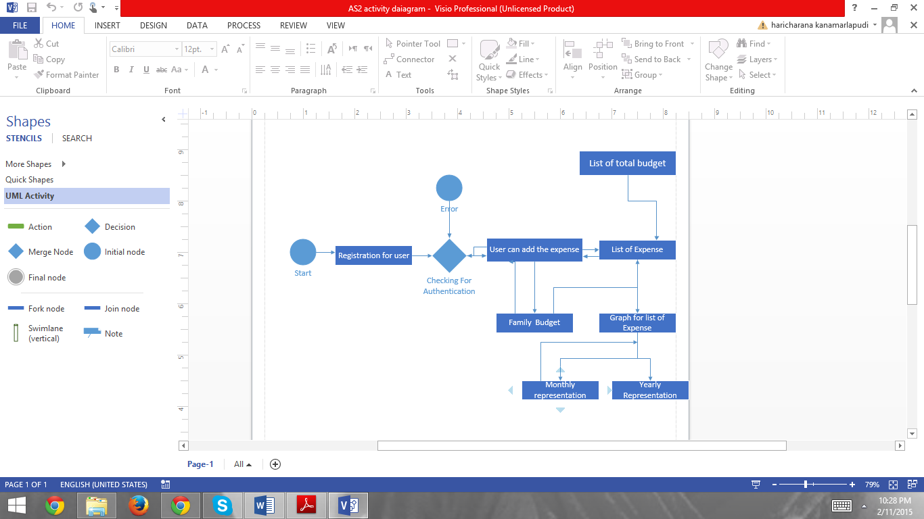

**V. PROJECT PLAN**

**Project goal and objectives:**

* **Overall goal:** The main goal ofBudget Analysis and Reminder Application is to maintain the day to day budgets with ease without any manual calculations. It also set limit to the budget and give a reminder when the limit is exceeded.
* **Problem statement:** Managing your finances will involve lot of paper work, calculations. All financial information was either written down on paper and should be stored in files and any financial planning that took place was mostly in one’s head.

But to plan the monthly budgets using Budget Analysis and Reminder is easy and that can help not only in managing money but also in handling all aspects of personal finance.

* **Significance:**
* Application allows user to set limit to budget and gives alert when cross the budget limit
* Application will automatically give a warning when category wise budget limit exceed
* Application allows user to perform operations like add new expense, delete expense, update, add new category, delete category and view budget
* User can also add or remove family members and also helps to maintain their individual expenses
* Application allows to view category wise budget and also each family member budget info
* Application generates a statistically report of the yearly and monthly budget using bar graphs, line charts

**Class Diagram:**

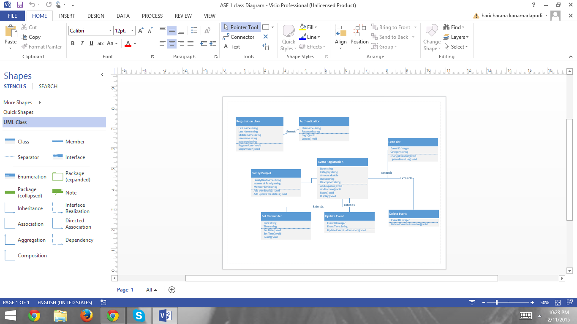

**Sequence Diagram:**

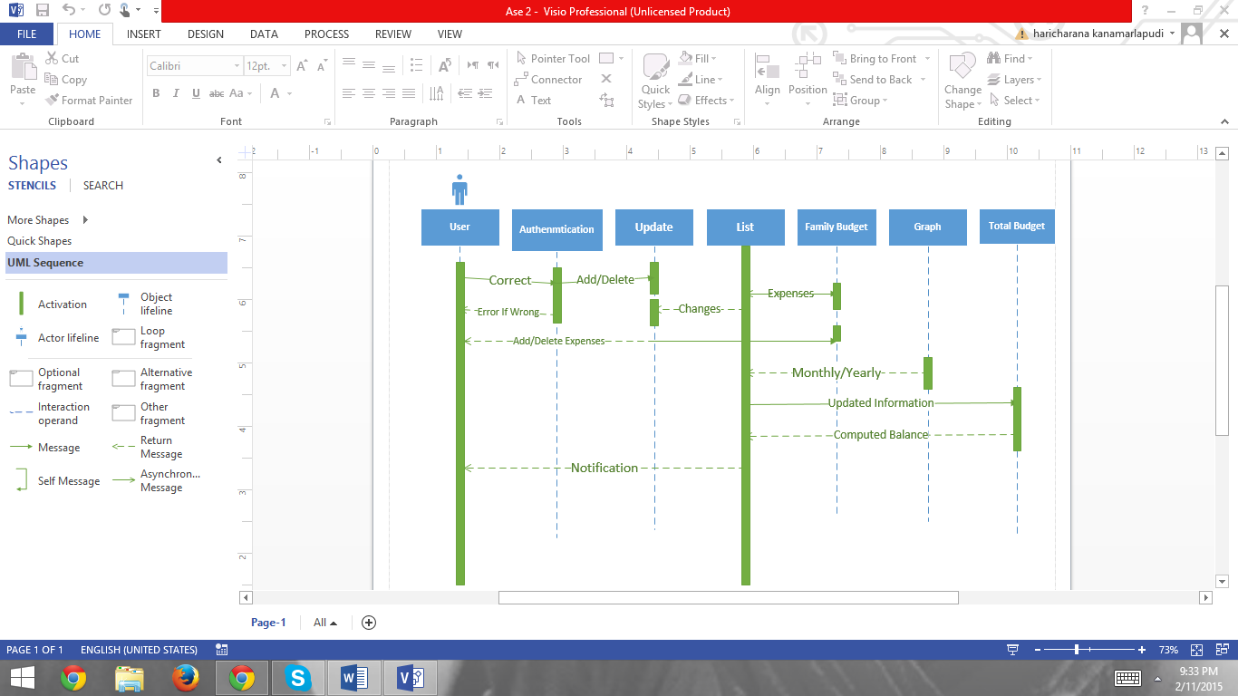

**VI. INCREMENT 1**

Firstly a welcome screen will be displayed with the App name “ Budget Analysis and Remainder” when we click on the App.



Second, a login screen with user name and password will appear. If the user is a new user and not hasn’t registered yet then it asks the user to register first.

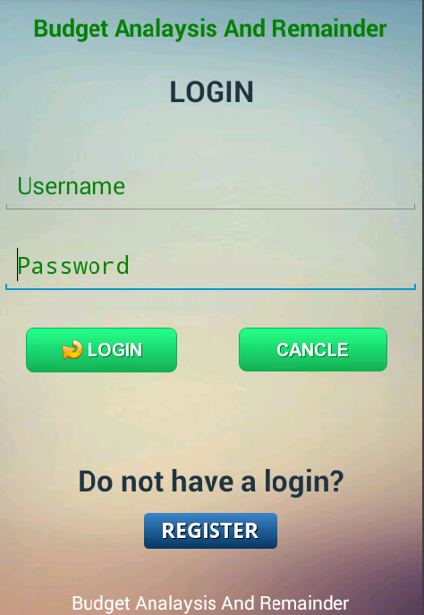

* If the user click on Register button then a new screen appear that helps user to create a new account.

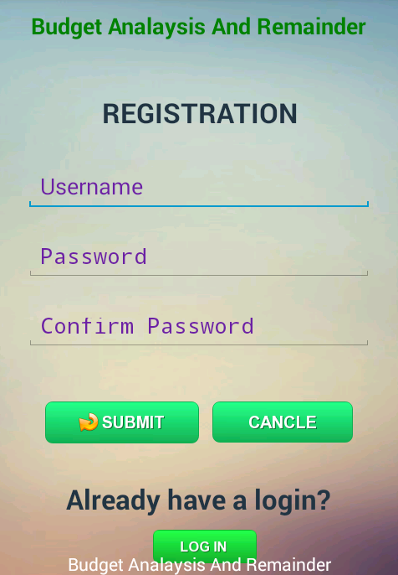

* Next, after registration the user can now login with his/ her username and password and access the services.

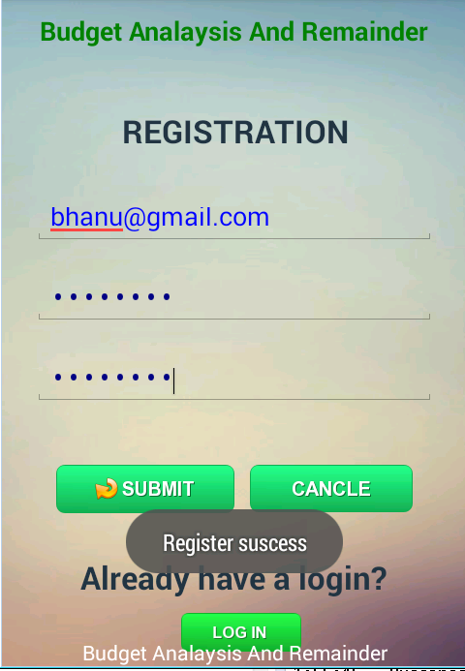

**Testing:**

The test cases are done for Login module and Registration module and observed the following outputs.

* **Positive Test cases:**
* Login Successful: If the user already has an account and during sign up process when user enters correct username and password then a message appear displaying “Login success”.

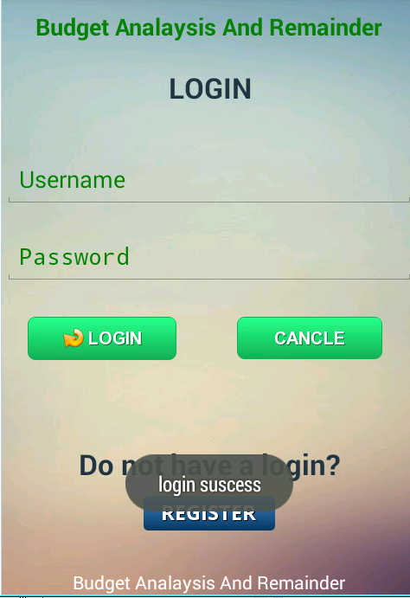

* Registration Successful: In the registration process when the user haven’t registered yet and a new user after providing correct credentials then a message will appear showing “ Registration Success”

**

* **Negative Test cases:**
* Invalid username or password: If the user already exists and during login process if the user enters a incorrect username or password that doesn’t exist or match the existing data records then an error message will displaying “ Enter correct password”

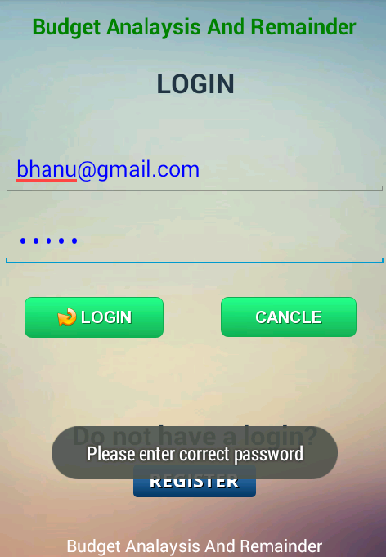

* Invalid Email ID: During the registration process the user needs to enter some credentials like preferred username, password, confirm password and Email ID. If the user enter wrong Email ID that doesn’t exist the a message appear displaying “Enter valid Email ID”

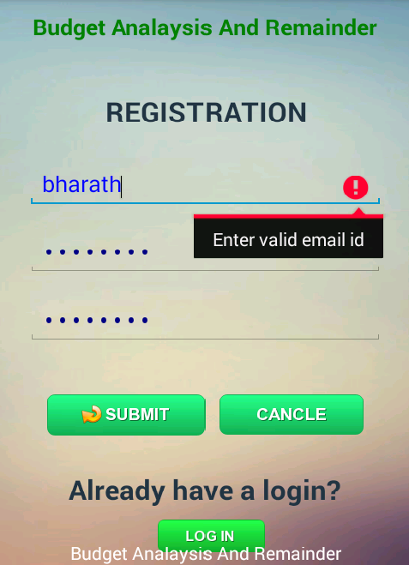

* Password Mismatch: During the user registration the user needs to enter a password and asked to reenter the password in order to confirm that password. When user enters two different passwords then an error message appear with “ Confirm password not matched”

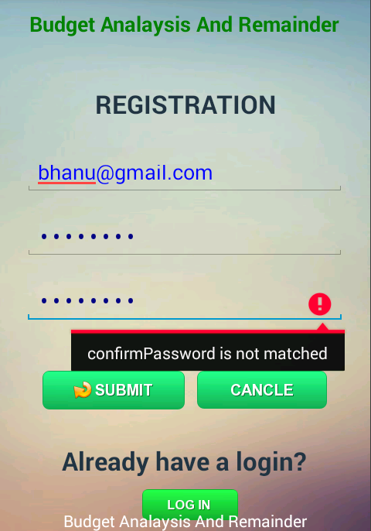

* User already exits: If the user already has an account and when tried to create a new account with same Email ID then error message appear with “ User already exist”

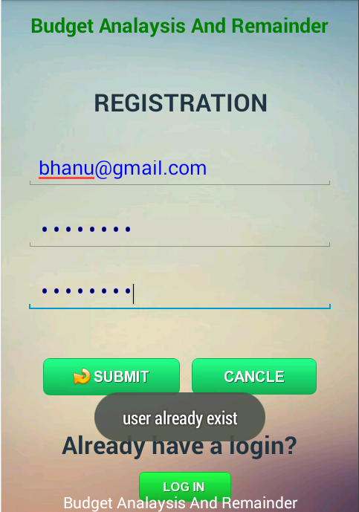

**VII. INCREMENT 2**

* After the successfully login into application an event registration page will appeared which contains the date, description, categorize, price fields. And on click on save button the event will be saved to database. On click on clear button all the fields will reset.

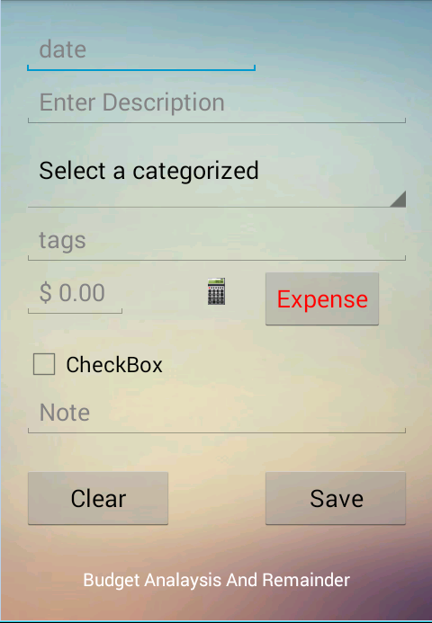

* The date on which you are creating the filled from this display menu

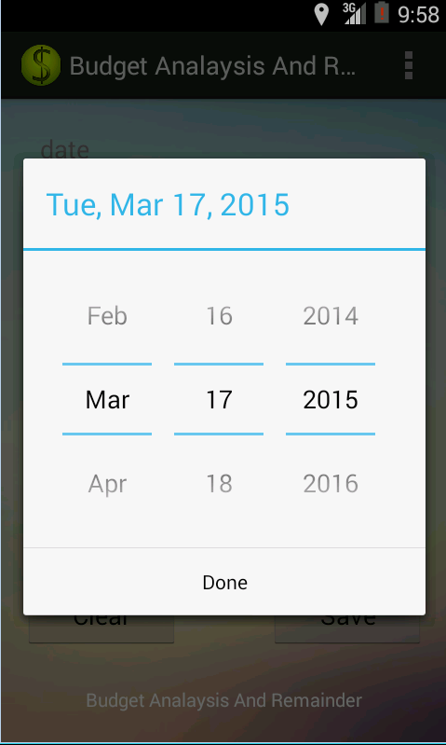

* An user can select the type of event he/she is adding from the dropdown list. He can also add category by typing the text in text field.

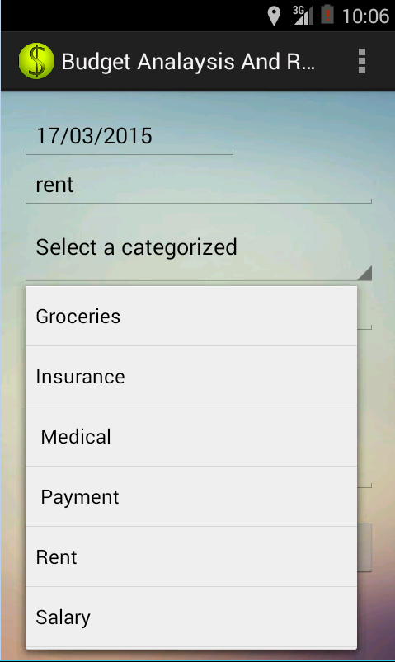

* After entering event details user clicks on submit so that the details will be saved into database.

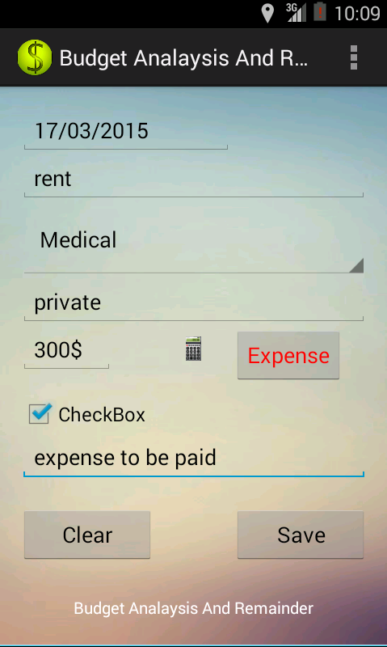

* User can also reset the event registration form if he entered wrong details or if he need it enter new event.

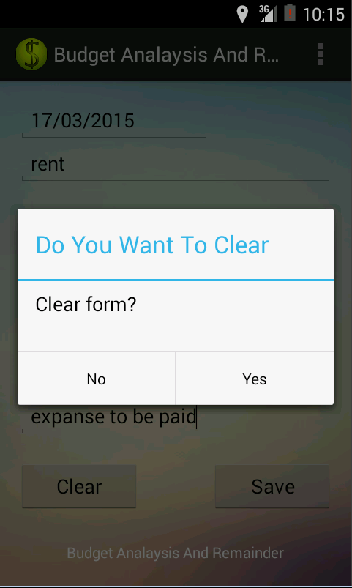

* **Testing:**

Manual testing is performed considering all positive and negative test cases

**Positive test cases**:

* If the user fills all the details and click on save button, the event details will be saved to database and displays a message update successful.



* If the user wants to clear the entered details he clicks on clear button so that it asks for confirmation to clear the event details.



**Negative test cases:**

* If the user keeps any of the field empty and clicks on save button, a dialog box appears showing the message event creation unsuccessful.

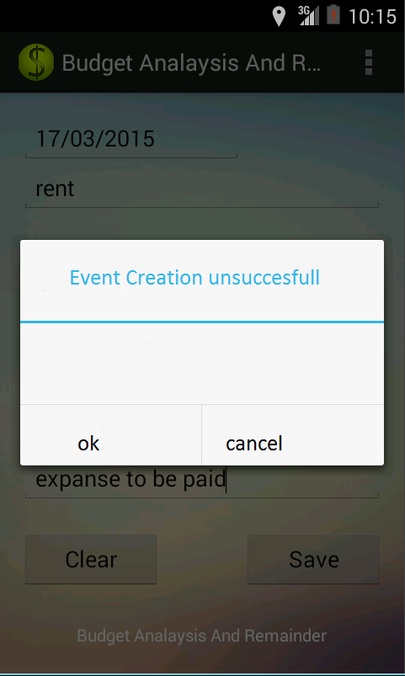

* If the user tries to update the event providing the wrong details such as date, a dialog box appears showing update unsuccessful.

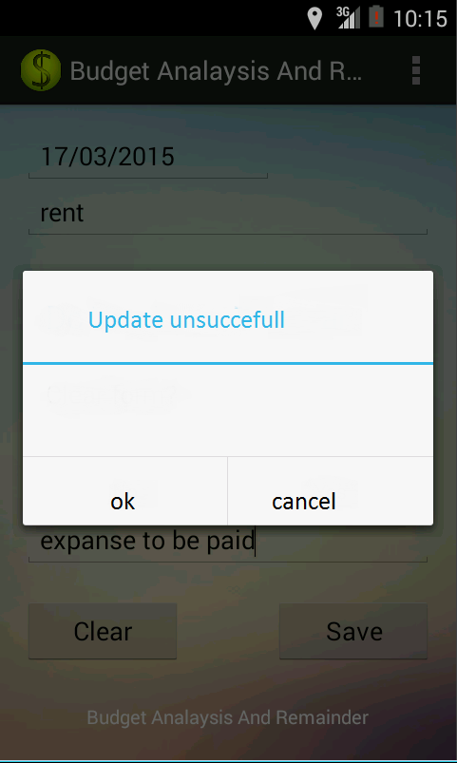

**VIII. INCREMENT 3**

* After the successful login by user a list of activities such as add new expense, view list, add family budget and view graph will be appeard on home screen.

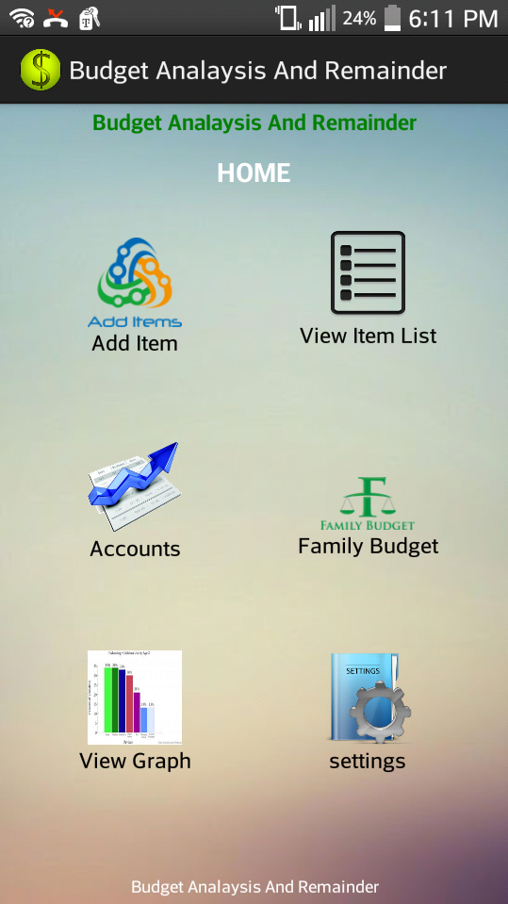

* user can add a new expense by selecting add item icon on home screen. Then user can add an expense by giving required credentials such as date, description and price. If all information is correct he selects save else user selects clear button.

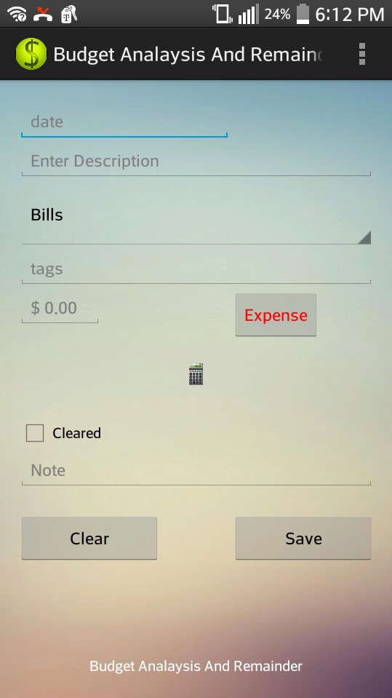

* User can add a family budget by selecting family budget from home screen. User also provides starting and ending dates for the budget.

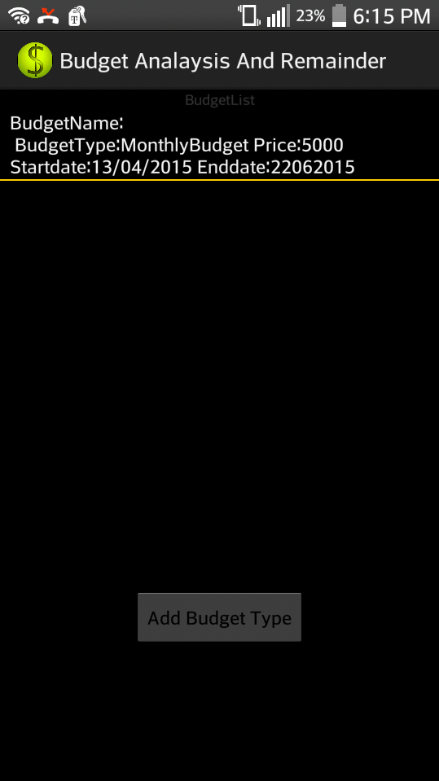

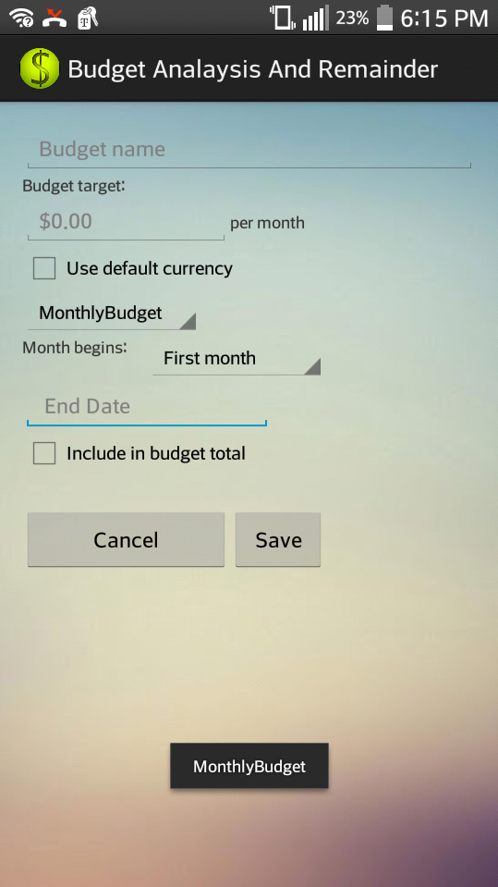

* User selects whether it is weekly, monthly or yearly budget from dropdown list. He can also provide starting and ending dates for the budget.

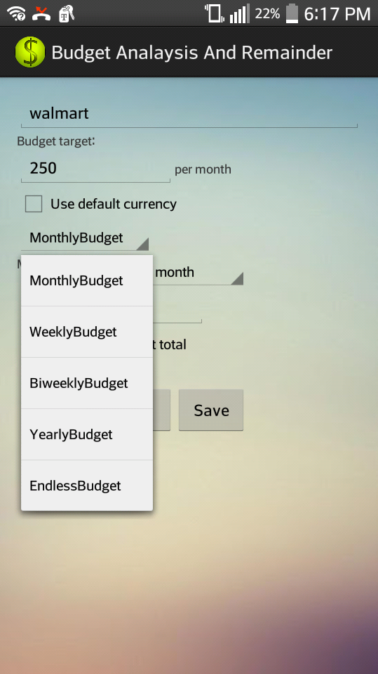

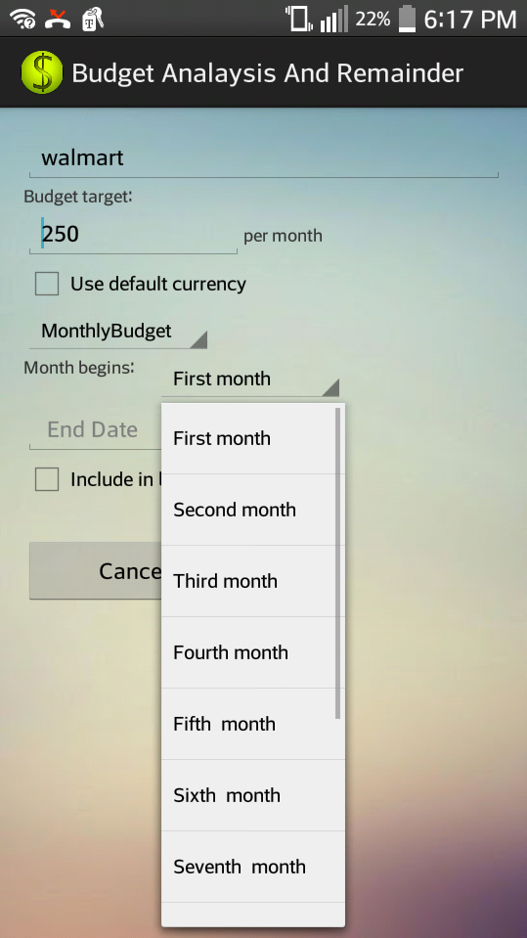

* After entering the details the user selects save button, then the details will be saved to database and can be viewed in a list.

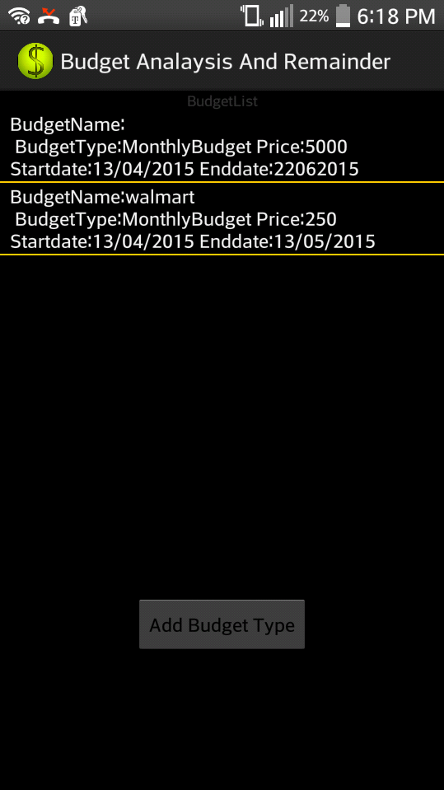

* **Testing:**

**Positive Test cases:-**

* When the user enters correct budget details and saves them it will be added to database and displays in a list

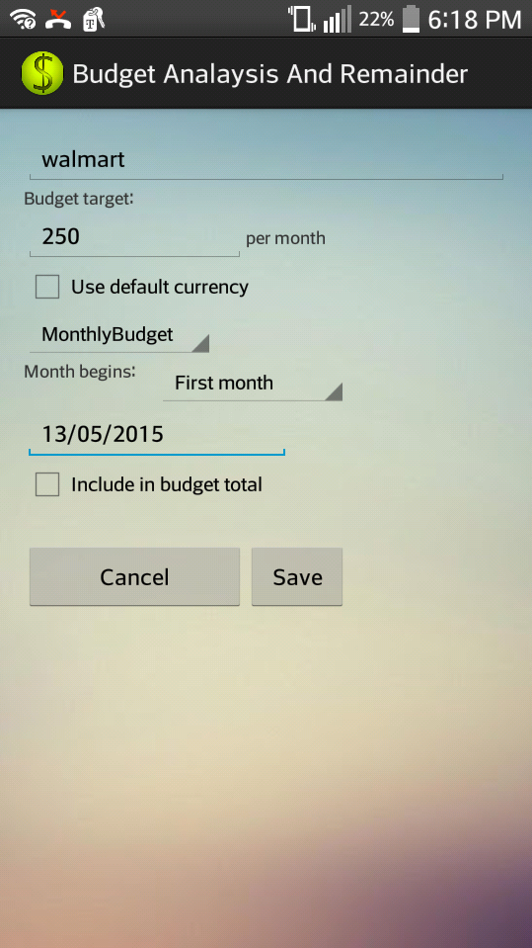



**Negative test cases:-**

* When the user tries to add the same expense for the second time a message will be displayed, as expense already exists

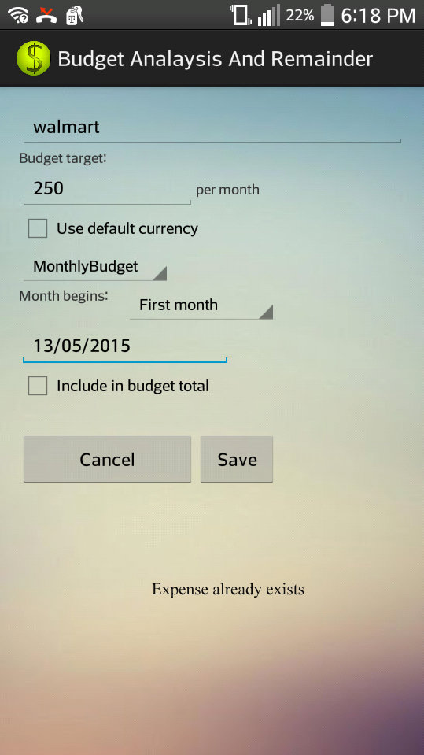

**IX. INCREMENT 4**

When the user successfully logins into application a home screen will be displayed

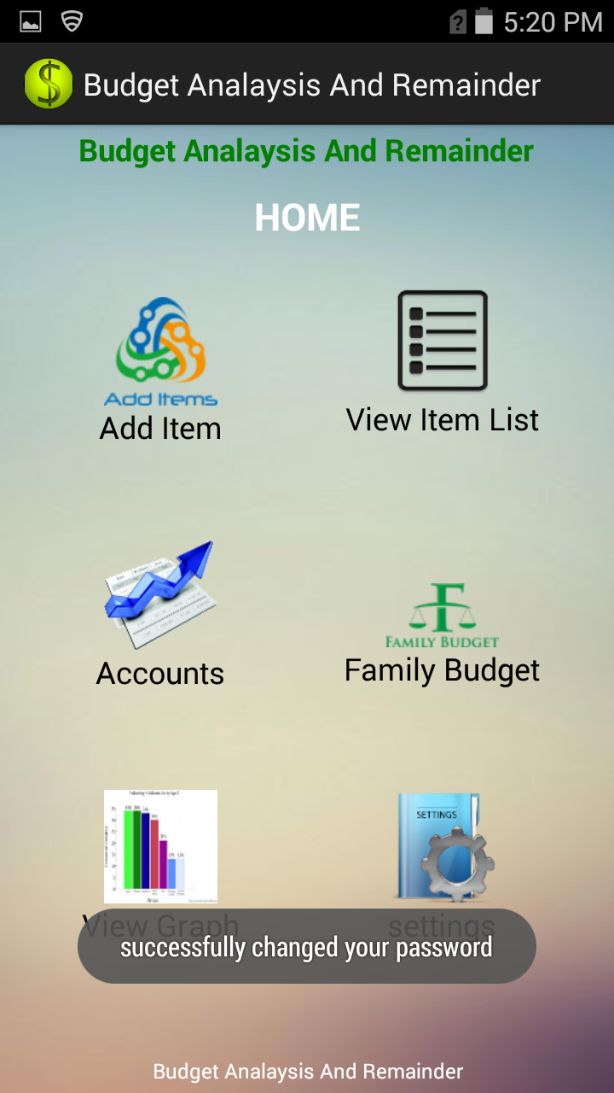

* Users have the facility to add budget of his/ her family members using multi login. User has facility to view expenses for separate users and also for the entire family

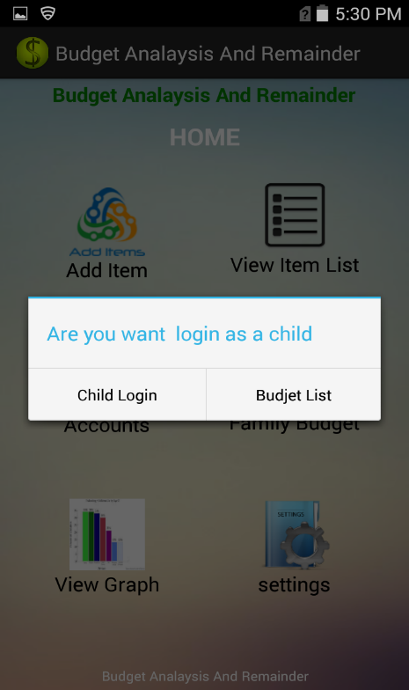

Only child budget can be viewed as

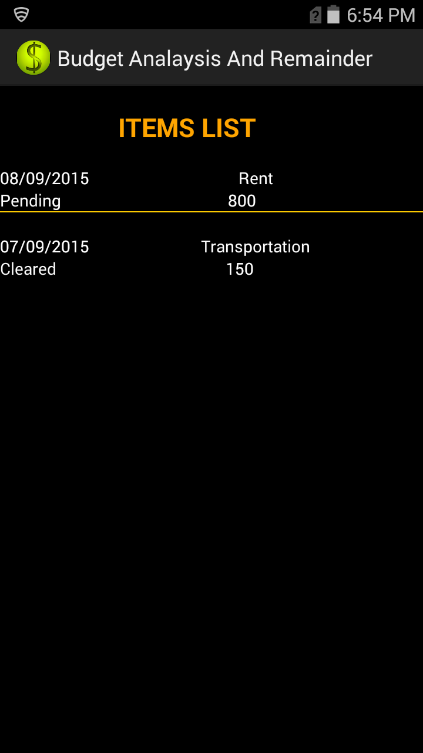

The entire family budget can be viewed as

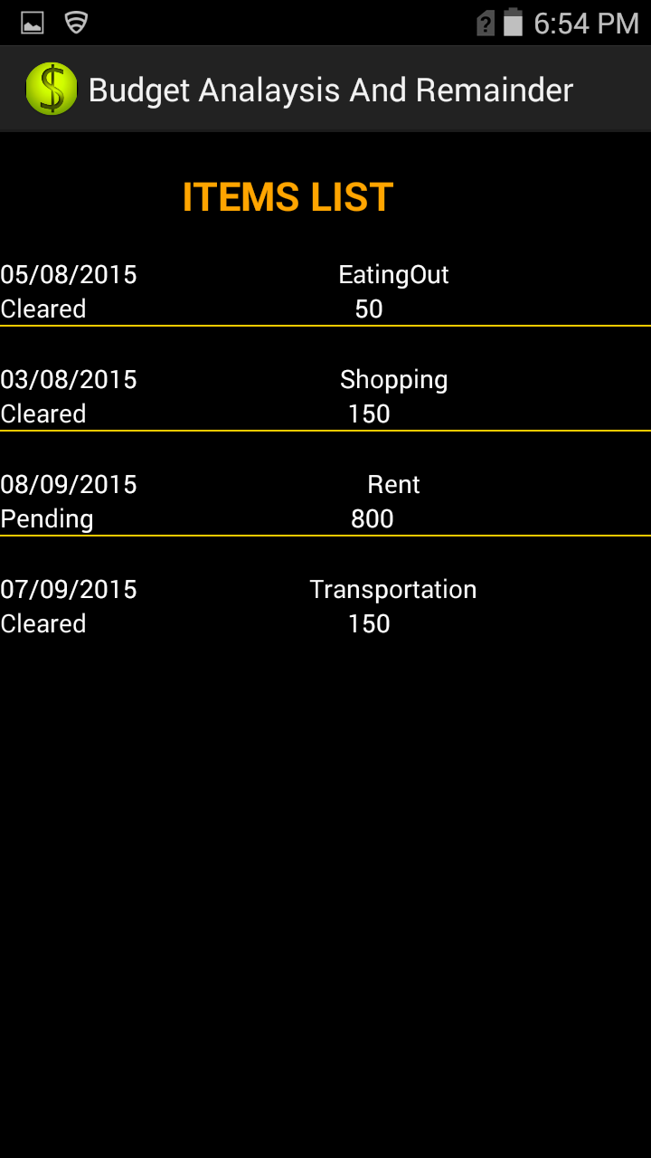

* When the budget of user exceeds the max value set by user it displays a message showing that user budget exceeded

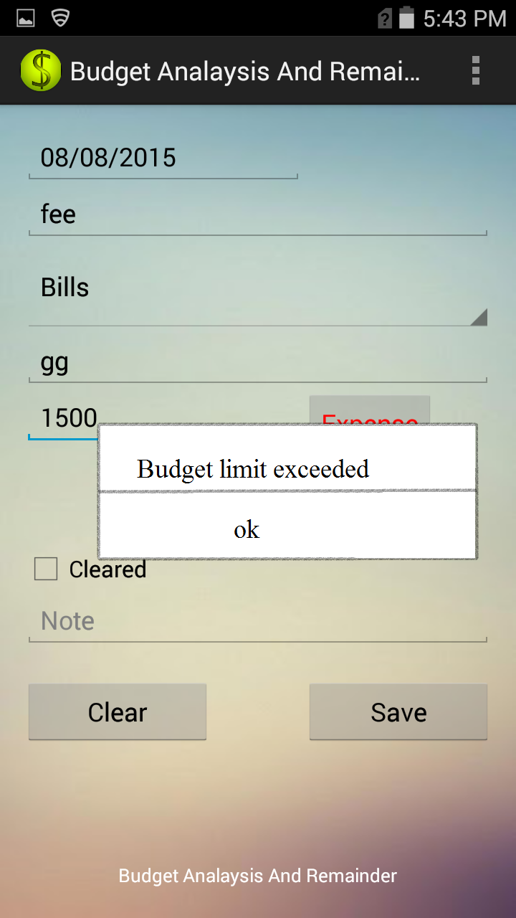

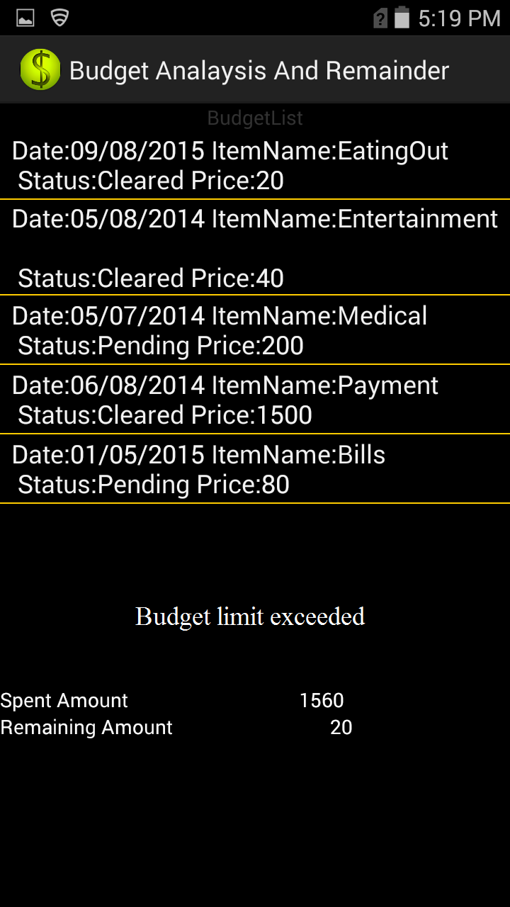

* To view all the expenses and budget details in a clear and quick view, he can select bar graph view from the home screen. It displays as

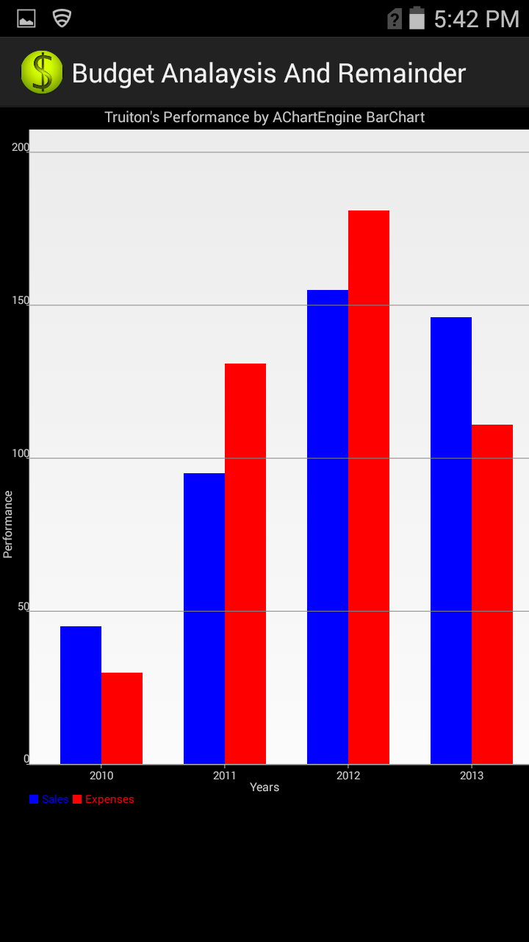

* User also has facility to manage his personnel details such as password change in order to secure his application.

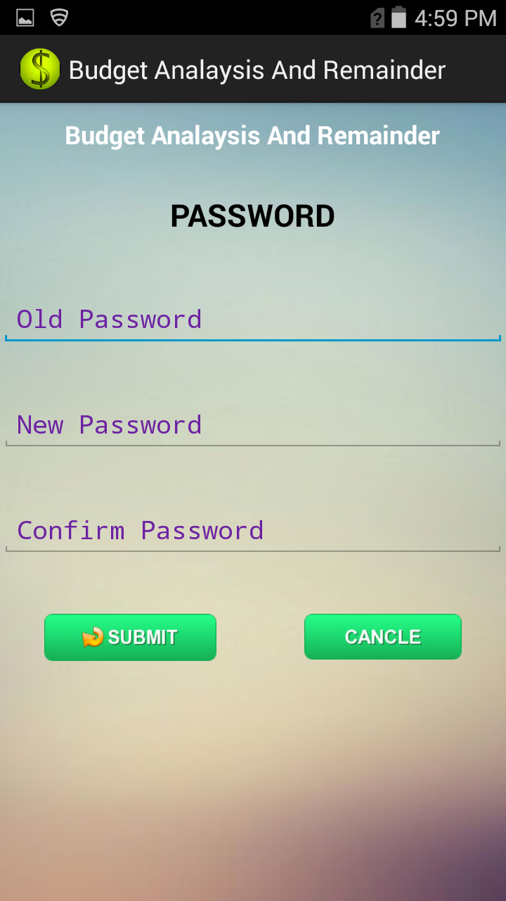

* The admin of the group has facility view, update and delete expenses of his own and also for family members

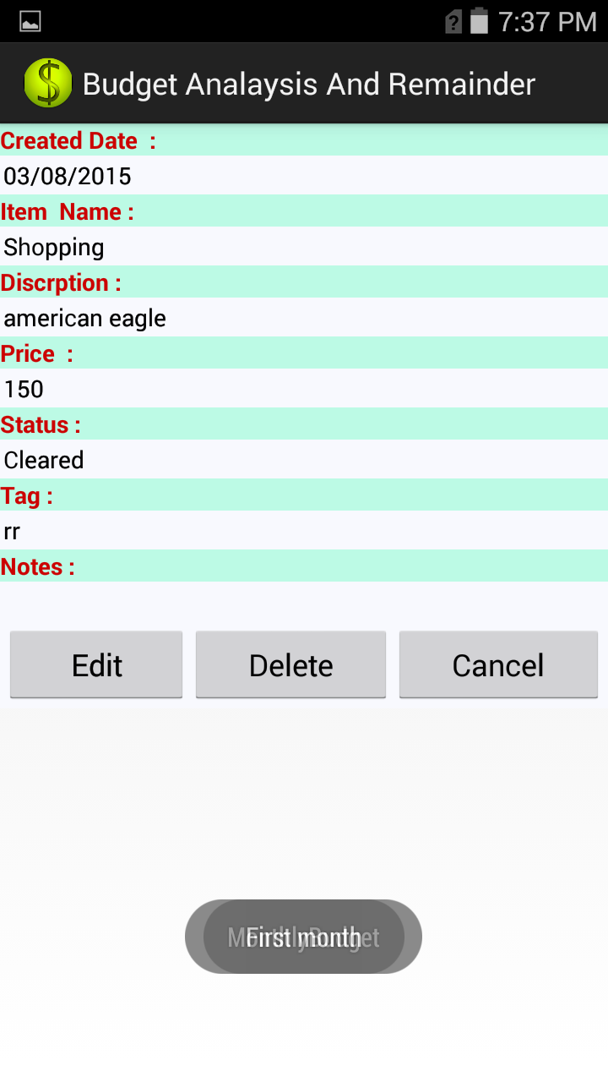

* **Testing:-**

**Positive test cases:-**

* User can successfully change his password from settings



* User can successfully update his expenses or delete if any modification needed.

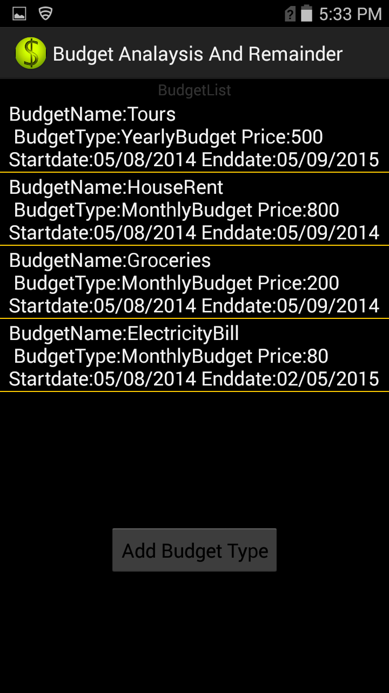

**Negative test cases:-**

* If user enters wrong current password or enters password without following proper rules then it displays error message.

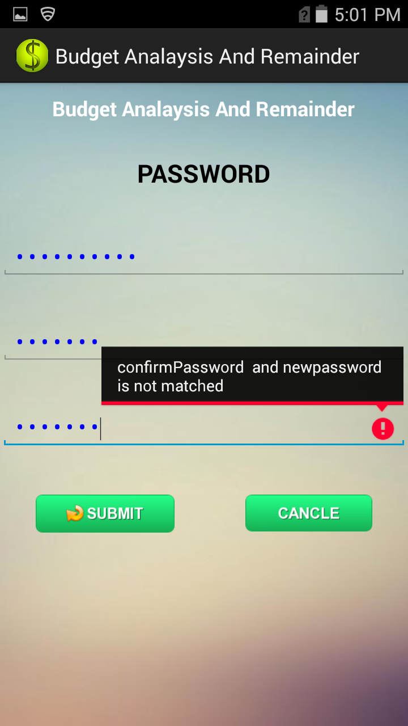

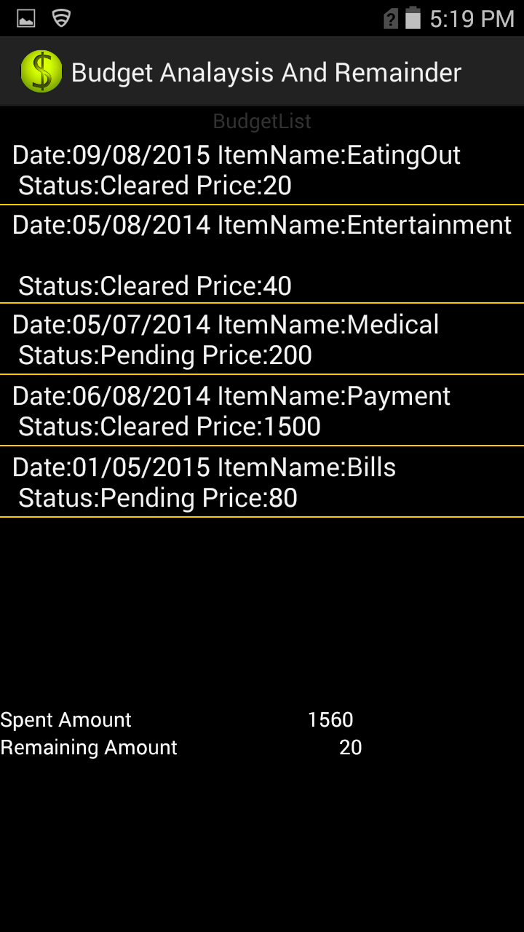

**X. PRESENTATION MATERIAL:**

**IBM Hackathon Spring 2015**

**Title: You Tube Ranking system**

















**Xi. URL and SCREENSHOT of VIDEO**

[**url:-**](url:-)[**https://www.youtube.com/watch?v=HnFIWCn1msw**](https://www.youtube.com/watch?v=HnFIWCn1msw)

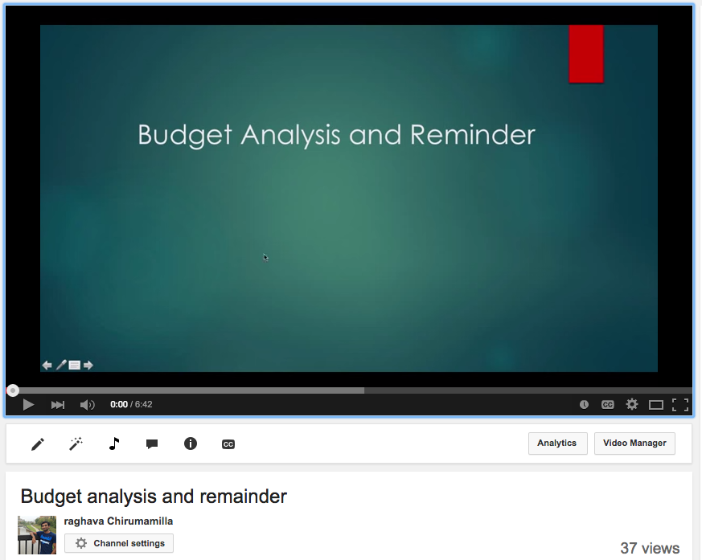

**Xii REFERENCES:-**

1. <https://google-developers.appspot.com/chart/interactive/docs/quick_start>
2. <http://developer.android.com/reference/packages.html>
3. <http://www.tutorialspoint.com/android/>
4. <http://developer.android.com/guide/topics/connectivity/index.html>

**Xiii. ACKNOWLEDGEMENT**

This work was done in partial fulfillment of the requirements of

CS551: Advanced Software Engineering,

CSEE Department,

University of Missouri – Kansas City (Fall 2014).

Instructor: Dr. Yugyung Lee,

TA: Malathy Krishnan, Chandra shekar, Mayanka

Download our YouTube Video here

<https://www.youtube.com/watch?v=HnFIWCn1msw>

Source code:-

Accountscreen.java

package com.example.bussinessanalsis;

import java.util.ArrayList;

import java.util.HashMap;

import java.util.List;

import com.example.bussinessanalsis.database.DataBaseConector;

import android.R.integer;

import android.app.Activity;

import android.content.SharedPreferences;

import android.os.Bundle;

import android.util.Log;

import android.view.View;

import android.widget.AdapterView;

import android.widget.ArrayAdapter;

import android.widget.ListView;

import android.widget.TextView;

public class AcountsScreen extends Activity {

DataBaseConector dbconnector;

ItemsDetails itemdetails;

String discrption,price,tag,note,date,sppinervalue,status;

ListView list;

ArrayList<HashMap<String, String>> arraylist;

HashMap<String, String> map = new HashMap<String, String>();

ArrayList<String> lists = new ArrayList<String>();

String result;

int spentprice,Budjetprice,totalprice;

TextView spent_text,remainintext;

@Override

public void onCreate(Bundle save)

{

super.onCreate(save);

setContentView(R.layout.acountslist);

list= (ListView)findViewById(R.id.account_list);

spent_text=(TextView)findViewById(R.id.spent_amount);

remainintext=(TextView)findViewById(R.id.remaining_amount);

dbconnector=new DataBaseConector(this);

SharedPreferences prefs = getSharedPreferences("", MODE_PRIVATE);

String userid = prefs.getString("userid", "");

List<ItemsDetails> itemlist=dbconnector.getAllItems(userid);

System.out.println("itemlist details: " + itemlist.size());

itemdetails=new ItemsDetails();

for( ItemsDetails itemdetails:itemlist)

{

arraylist = new ArrayList<HashMap<String, String>>();

String Price= itemdetails.getPrice();

String Date= itemdetails.getDate();

String Discription= itemdetails.getDiscrption();

String sppinerval =itemdetails.getSppinervalue();

String notes=itemdetails.getNote();

String tag=itemdetails.getTag();

String status=itemdetails.getStatus();

result="Date:"+Date+" "+"ItemName:" +sppinerval+" \n"+" Status:"+status+" "+"Price:"+Price;

map.put("Date", Date);

map.put("Discription", Discription);

map.put("sppinerval", sppinerval);

map.put("notes", notes);

map.put("Date", Date);

map.put("Price", Price);

map.put("Date", Date);

arraylist.add(map);

System.out.println("map details: " + arraylist.size());

Log.i("the result values",result);

lists.add(result);

}

ArrayAdapter adapter1=new ArrayAdapter(getApplicationContext(),android.R.layout.simple_list_item_1,lists);

list.setAdapter(adapter1);

list.setOnItemClickListener(new AdapterView.OnItemClickListener()

{

@Override

public void onItemClick(AdapterView<?> arg0, View arg1, int arg2,

long arg3) {

}

});

int spentprice=dbconnector.price_list();

Log.v("tagActivity", "@ price status " + spentprice);

int Budjetprice=dbconnector.budget_price_list();

Log.v("tagActivity", "@ price status " + Budjetprice);

if(spentprice!=0)

{

spent_text=(TextView)findViewById(R.id.spent_amount);

spent_text.setText(String.valueOf(spentprice));

if(Budjetprice!=0)

{

remainintext=(TextView)findViewById(R.id.remaining_amount);

int totalprice=Budjetprice-spentprice;

remainintext.setText(String.valueOf(totalprice));

}

}

}}

**additems.java**

package com.example.bussinessanalsis;

import java.security.PublicKey;

import java.text.SimpleDateFormat;

import java.util.ArrayList;

import java.util.Calendar;

import java.util.HashMap;

import java.util.List;

import java.util.Locale;

import com.example.bussinessanalsis.database.DataBaseConector;

import android.app.Activity;

import android.app.AlertDialog;

import android.app.DatePickerDialog;

import android.app.DatePickerDialog.OnDateSetListener;

import android.content.ContentValues;

import android.content.DialogInterface;

import android.content.Intent;

import android.content.SharedPreferences;

import android.graphics.Color;

import android.os.Bundle;

import android.text.InputType;

import android.text.TextUtils;

import android.util.Log;

import android.view.LayoutInflater;

import android.view.Menu;

import android.view.View;

import android.view.View.OnClickListener;

import android.widget.AdapterView;

import android.widget.ArrayAdapter;

import android.widget.Button;

import android.widget.CheckBox;

import android.widget.DatePicker;

import android.widget.EditText;

import android.widget.ListView.FixedViewInfo;

import android.widget.Spinner;

import android.widget.Toast;

import android.widget.AdapterView.OnItemSelectedListener;

public class Additems extends Activity implements OnClickListener {

DatePicker picker;

Button displayDate;

EditText et;

private SharedPreferences prefs;

private String prefName = "spinner_value";

int id=0;

Button cal;

String oper = "";

String discrption,price,tag,note,date,sppinervalue,status;

Spinner sp;

DataBaseConector dbconnector;

ArrayList<HashMap<String, String>> arraylist;

EditText fromDateEtxt,et_discription,et_tag,et_price,et_note;

Button b1,clear;

EditText etNum1;

EditText etNum2;

Button btnAdd;

Button btnSave,btnSub;

Button btnMult;

Button btnDiv;

CheckBox chkSelect;

private DatePickerDialog fromDatePickerDialog;

private SimpleDateFormat dateFormatter;

@Override

protected void onCreate(Bundle savedInstanceState) {

super.onCreate(savedInstanceState);

setContentView(R.layout.add_register_itam);

cal=(Button)findViewById(R.id.btn_cal);

btnSave=(Button)findViewById(R.id.btn_save);

dateFormatter = new SimpleDateFormat("dd/MM/yyyy", Locale.US);

dbconnector=new DataBaseConector(this);

/* etNum1 = (EditText) findViewById(R.id.etNum1);

etNum2 = (EditText) findViewById(R.id.etNum2);*/

et_discription = (EditText) findViewById(R.id.editText1);

et_tag = (EditText) findViewById(R.id.editText2);

et_price = (EditText) findViewById(R.id.editText3);

et_note = (EditText) findViewById(R.id.editText4);

chkSelect=(CheckBox)findViewById(R.id.checkBox1);

btnSave.setOnClickListener(new View.OnClickListener() {

@Override

public void onClick(View v) {

tag = et_tag.getText().toString();

price= et_price.getText().toString();

date=fromDateEtxt.getText().toString();

discrption= et_discription.getText().toString();

if(chkSelect.isChecked())

{

Log.i("clead on check box","status cleared");

status="Cleared";

}

else

{

status="Pending";

}

if(date.length()==0)

{

fromDateEtxt.setError(" Date Field is Empty");

fromDateEtxt.requestFocus();

return;

}

if(discrption.length()==0)

{et_discription.setError(" Discrption Field is Empty");

et_discription.requestFocus();

return;

}

if(price.length()==0)

{

et_price.setError(" Price Field is Empty");

et_price.requestFocus();

return;

}

if(tag.length()==0)

{

et_tag.setError(" tag Field is Empty");

et_tag.requestFocus();

return;

}

SharedPreferences prefs = getSharedPreferences("", MODE_PRIVATE);

String userid = prefs.getString("userid", "");

discrption = discrption.replace(" " , "");

Log.i("discrption",discrption);

tag = tag.replace(" " , "");

Log.i("the tag",tag);

note=et_note.getText().toString();

sppinervalue=sp.getSelectedItem().toString();

Log.i("the vlaues",discrption.trim()+"||"+price+"||"+tag.trim()+"||"+note+"||"+date+"||"+sppinervalue);

ContentValues additems= new ContentValues();

//(reg_userid text, discrption text, price text,tag text,note text,date text,sppinervalue text )";

additems.put("reg_userid", userid);

additems.put("discrption", discrption.trim());

additems.put("price", price);

additems.put("tag", tag.trim());

additems.put("note", note);

additems.put("date", date);

additems.put("sppinervalue", sppinervalue);

additems.put("status", status);

Log.i("the inserted items",additems.toString());

dbconnector.insert_items(additems);

clear();

Intent i = new Intent(Additems.this,ViewItemsList.class);

startActivity(i);

}

}) ;

cal.setOnClickListener(new View.OnClickListener() {

@Override

public void onClick(View v) {

// TODO Auto-generated method stub

LayoutInflater li = LayoutInflater.from(getBaseContext());

View promptsView = li.inflate(R.layout.calc, null);

AlertDialog.Builder alertDialogBuilder = new AlertDialog.Builder(

Additems.this);

alertDialogBuilder.setView(promptsView);

alertDialogBuilder

.setCancelable(false)

.setPositiveButton("OK",

new DialogInterface.OnClickListener() {

public void onClick(DialogInterface dialog,int id) {

}

})

.setNegativeButton("Cancel",

new DialogInterface.OnClickListener() {

public void onClick(DialogInterface dialog,int id) {

dialog.cancel();

}

});

// create alert dialog

AlertDialog alertDialog = alertDialogBuilder.create();

// show it

alertDialog.show();

}

});

findViewsById();

setDateTimeField();

List<String> list=new ArrayList<String>();

list.add("Select a categorized");

list.add("Uncategorized");

list.add("Bills");

list.add("Clothing");

list.add("Deposit");

list.add("EatingOut");

list.add("Entertainment");

list.add("Gifts");

list.add("Groceries");

list.add("Insurance");

list.add("Medical");

list.add("Payment");

list.add("Rent");

ist.add("Salary");

list.add("Shopping");

list.add("Transfer");

list.add("Transportation");

list.add("Utilities");

sp=(Spinner) findViewById(R.id.spinner1);

b1=(Button)findViewById(R.id.button2);

clear=(Button)findViewById(R.id.button3);

b1.setTextColor( Color.RED );

b1.setOnClickListener( new OnClickListener() {

@Override

public void onClick(View v) {

b1.setText("Income");

b1.setTextColor(Color.GREEN );

}

});

ArrayAdapter<String> adp= new ArrayAdapter<String>(this,

android.R.layout.simple_list_item_1,list);

adp.setDropDownViewResource(android.R.layout.simple_spinner_dropdown_item);

sp.setAdapter(adp);

prefs = getSharedPreferences(prefName, MODE_PRIVATE);

id=prefs.getInt("last_val",0);

sp.setSelection(id);

sp.setOnItemSelectedListener(new OnItemSelectedListener() {

@Override

public void onItemSelected(AdapterView<?> arg0,

View arg1,int pos, long arg3) {

prefs = getSharedPreferences(prefName, MODE_PRIVATE);

SharedPreferences.Editor editor = prefs.edit();

//---save the values in the EditText view to preferences---

editor.putInt("last_val", pos);

editor.commit();

Toast.makeText(getBaseContext(),

sp.getSelectedItem().toString(), Toast.LENGTH_SHORT).show();

}

@Override

public void onNothingSelected(AdapterView<?> arg0) {

// TODO Auto-generated method stub

}});

clear.setOnClickListener(new OnClickListener() {

@Override

public void onClick(View arg0) {

AlertDialog.Builder alertDialogBuilder = new AlertDialog.Builder(Additems.this);

// set title

alertDialogBuilder.setTitle("Do You Want To Clear");

// set dialog message

alertDialogBuilder

.setMessage("Clear form?")

.setCancelable(false)

.setPositiveButton("Yes",new DialogInterface.OnClickListener() {

public void onClick(DialogInterface dialog,int id) {

// if this button is clicked, close

// current activity

clear();

//Additems.this.finish();

}})

.setNegativeButton("No",new DialogInterface.OnClickListener() {

public void onClick(DialogInterface dialog,int id) {

// if this button is clicked, just close

// the dialog box and do nothing

dialog.cancel();});

// create alert dialog

AlertDialog alertDialog = alertDialogBuilder.create();

// show it

alertDialog.show();

}

});

}

private void findViewsById() {

fromDateEtxt = (EditText) findViewById(R.id.editText5);

fromDateEtxt.setInputType(InputType.TYPE_NULL);

fromDateEtxt.requestFocus();

}

private void setDateTimeField() {

fromDateEtxt.setOnClickListener(this);

Calendar newCalendar = Calendar.getInstance();

fromDatePickerDialog = new DatePickerDialog(this, new OnDateSetListener() {

public void onDateSet(DatePicker view, int year, int monthOfYear, int dayOfMonth) {

Calendar newDate = Calendar.getInstance();

newDate.set(year, monthOfYear, dayOfMonth);

fromDateEtxt.setText(dateFormatter.format(newDate.getTime()));

}},newCalendar.get(Calendar.YEAR),

newCalendar.get(Calendar.MONTH), newCalendar.get(Calendar.DAY_OF_MONTH));

}

@Override

public boolean onCreateOptionsMenu(Menu menu) {

// Inflate the menu; this adds items to the action bar if it is present.

getMenuInflater().inflate(R.menu.main, menu);

return true;}

private void clear() {

fromDateEtxt.setText(" ");

et_discription.setText("");

et_tag.setText(" ");

et_price.setText(" ");

et_note.setText("");

}

@Override

public void onClick(View view) {

if(view == fromDateEtxt) {

fromDatePickerDialog.show();

/* // TODO Auto-generated method stub

float num1 = 0;

float num2 = 0;

float result = 0;

// check if the fields are empty

if (TextUtils.isEmpty(etNum1.getText().toString())

|| TextUtils.isEmpty(etNum2.getText().toString())) {

return;

}

// read EditText and fill variables with numbers

num1 = Float.parseFloat(etNum1.getText().toString());

num2 = Float.parseFloat(etNum2.getText().toString());

// defines the button that has been clicked and performs the corresponding operation

// write operation into oper, we will use it later for output

switch (view.getId()) {

case R.id.btnAdd:

oper = "+";

result = num1 + num2;

break;

case R.id.btnSub:

oper = "-";

result = num1 - num2;

break;

case R.id.btnMult:

oper = "*";

result = num1 * num2;

break;

case R.id.btnDiv:

oper = "/";

result = num1 / num2;

break;

default:

break;

}

} */

} }}